Required practical activity: preparation of a pure, dry sample of a soluble salt from an insoluble oxide or carbonate, using a Bunsen burner to heat dilute acid and a water bath or electric heater to evaporate the solution
Required Practical Guide – Making Salts

Aim: To prepare a dry sample of soluble salt

Notes and guidance

Plan the follow-up lesson to be at least two days after this experiment to give the salt time to crystallise. Discuss your plan with your technician in advance so they know for how long to keep the crystals.

Copper (II) oxide powder should be added a very small amount at a time to avoid waste.

You may wish to have students collect the equipment for this themselves from communal trays at the front of the lab. This will help them to develop their skills of equipment recognition and organisation. However, if this is impractical, ask your technician colleagues if they are able to set up individual sets at student workstations. Ensure each group has sufficient space to use a Bunsen burner and pour chemicals safely.

There are a lot of steps to this practical. If your students struggle to follow written instructions, it is advisable to stop the class after each step and deliver instructions for how to proceed. An added advantage of this is that you can add extra theory into your narration and explain why each step is being done.

Soluble salt samples can be prepared in a variety of different ways. The method outlined in this practical guide aligns closely with CLEAPSS recommendations, but you may wish to demonstrate other methods. In particular, there is an accompanying video guide to this practical that demonstrates the method recommended by AQA. Certain unique steps in this method – such as using a Bunsen burner to heat the sulfuric acid – may feature in a future exam, but carry the potential for accidents to occur in the lab. Discuss this practical with your technician colleagues while planning to decide upon the safest method for the practical/demo.
Risk Assessment Notes
A risk assessment must be completed for this practical. The risk assessment should be specific to the class involved and written only by the teaching member of staff. For more guidance refer to CLEAPSS. It is good practice for students to wear safety spectacles during all class practicals and demos.

Soluble salt samples can be prepared in a variety of different ways. The method outlined in this practical guide aligns closely with CLEAPSS recommendations, but you may wish to demonstrate other methods. In particular, there is an accompanying video guide to this practical that demonstrates the method recommended by AQA. Certain unique steps in this method – such as using a Bunsen burner to heat the sulfuric acid – may feature in a future exam, but carry the potential for accidents to occur in the lab. Discuss this practical with your technician colleagues while planning to decide upon the safest method for the practical/demo.

1 M sulfuric acid is currently classed as a corrosive and irritant hazard. Ensure eye protection is worn at all times. For waste disposal, dilute to 0.1 M or weaker or neutralise with 1 M sodium carbonate solution and pour down foul-water drain. Refer to CLEAPSS Hazcard 98A.
Copper (II) oxide is currently classed as harmful if swallowed or inhaled and a cause of skin and eye irritation. It is toxic to aquatic life. Take extreme care while handling it and wear eye protection. For waste disposal, react a maximum of 24 g in 1 l of warm 1 M ethanoic acid before pouring down a foul-water drain. Refer to CLEAPSS Hazcard 26.

Copper sulfate solution is currently classed as corrosive and irritant hazard. Ensure eye protection is worn at all times. Copper sulfate solution must be left in a secure location to crystallise. If you believe there is a risk of the evaporating dishes being disturbed in your lab, ask your technician colleagues to store them in a prep room. For waste disposal, dilute to below 0.2 M and pour down a foul-water drain or your technician colleagues can use crystals for future practicals. Never allow students to take crystals home with them. Refer to CLEAPSS Hazcard 27C.

Equipment Per Group | Chemicals:  - 1 M sulfuric acid  - Copper(II) oxide powder  - Anti-bumping granules  - Access to hot water (kettle)  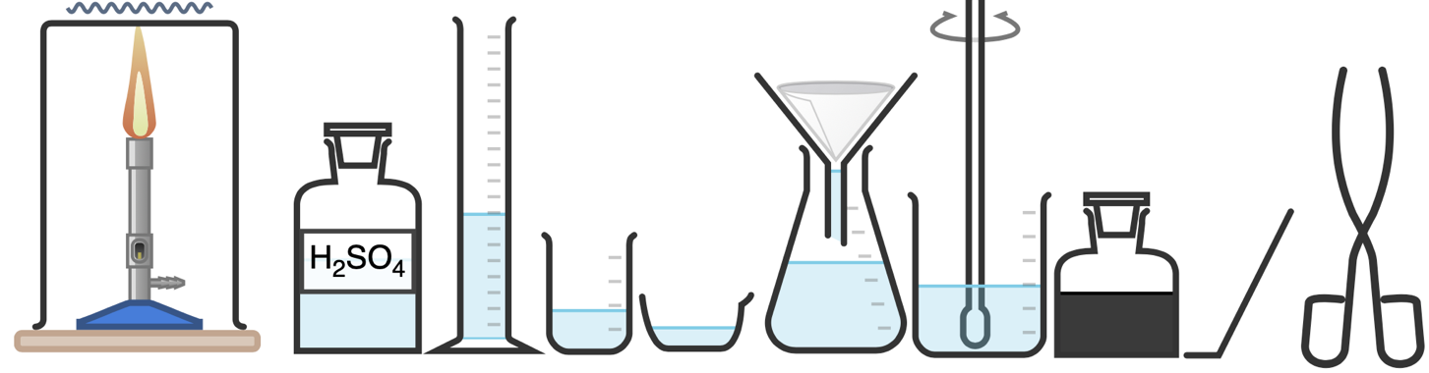  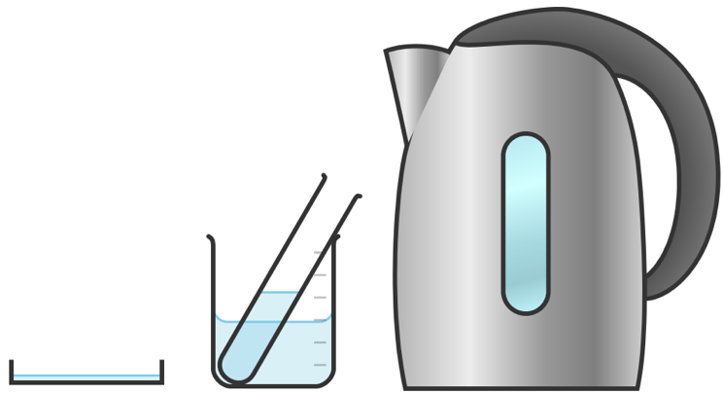
Apparatus:
- 25 ml Measuring cylinder
- Spatula
- Glass rod
- Boiling Tube
- 250 ml beaker
- Bunsen burner
- Tripod
- Gauze
- Heatproof mat
- Spints (wooden)
- Filter funnel and paper
- 100 ml conical flask
- Tongs
- Petri dish

Method |  | Questions To Ask Students During The Practical
- Add 15 ml sulfuric acid to the boiling tube.  - Place the boiling tube into a beaker water bath of water from a just-boiled kettle.  - After a couple of minutes, when the acid has had a chance to heat up, add a small amount of copper (II) oxide powder with the spatula.  - Place the boiling tube back into the water bath and stir the solution with the glass rod until the powder disappears and the solution turns blue.  - Keep adding copper (II) oxide a small amount at a time.  - Stop adding copper (II) oxide when some remains after stirring.  - Filter the contents of the boiling tube with the filter paper and funnel into the conical flask.  - Add a couple of anti-bumping granules to the conical flask.  - Stand the conical flask on a tripod and gauze and heat from beneath with a Bunsen burner until it just starts to boil.  - Use the tongs to remove the conical flask from the tripod and pour the hot solution into a petri dish.  - If crystals do not begin to form after 5-10 minutes, a wooden splint can placed into the solution to provide a rough surface for the crystals to grow on. |  | - What piece of equipment will you use to measure 15 ml of sulfuric acid? (Measuring cylinder.)  - Why do we heat the acid in the water bath before we add copper (II) oxide powder? (When hot, sulfuric acid can dissolve more copper (II) oxide powder and therefore make a more concentrated solution of copper sulfate.)  - How else could we heat the sulfuric acid? (We could heat the sulfuric acid by heating with a Bunsen burner, however this would lead to the possibility of boiling the acid and increase the risk of injury.)  - Why add only a small amount of copper oxide powder at a time and not all at once? (To avoid oversaturating the solution to such an extent that it is hard to filter and copper oxide powder is wasted.)  - Why filter the solution? (To remove any excess copper oxide powder or other solids in the solution.)  - Why do we add anti-bumping granules to the conical flask before heating? (To aid smooth boiling and to reduce the likelihood of violent bubbling and spitting.)  - What steps will you take before switching on the Bunsen burner to ensure doing so is safe? (Check burner and tubing for damage, ensure air hole is closed for safety flame, ensure area around burner is clear of hazards.)
Alternative Methods/Computer Simulations |  | Clearing up
Many types of salt crystals can be made in this manner. Copper sulfate is an excellent choice because its blue colour makes the crystals easier to see. However, if copper oxide is not available, consider making magnesium sulfate crystals using the same method but substituting magnesium carbonate powder for the copper oxide.  AQA suggest using a Bunsen burner to pre-heat the acid and crystallising in an evaporating dish – see video for this method.  As a stretch activity, you may wish to crystallise copper sulfate using varying methods and compare the crystals. If you evaporate most of the solution using a Bunsen burner then the crystals will be smaller than those that have been left to evaporate naturally. |  | It is important that equipment is returned to the prep room in good order. If safe to do so, rinse used equipment and put it in the used equipment tray. If the trays arrived on a trolley, students must return all trays and equipment to that trolley. Anything dirty needs to be placed into a separate container for washing up. Never put dirty equipment back into a tray with clean equipment.  The equipment will likely be very hot after heating. If it is too hot to clear away safely by the end of the lesson, alert the technician.  Ensure your technician colleague knows to not clear away the crystallising dishes until after the class has seen their results.
Sample Results |  | Possible Erroneous Results
 |  | 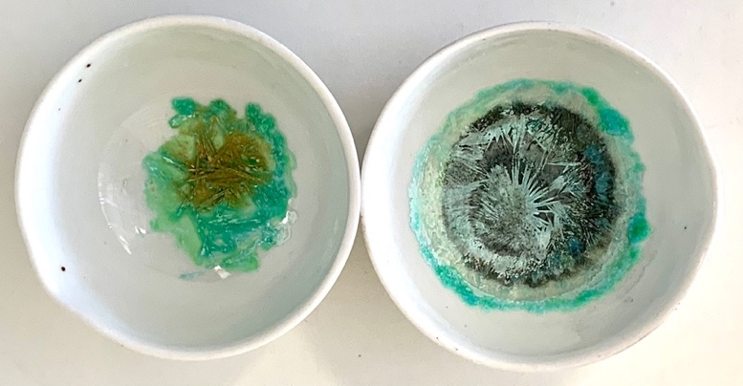
Questions To Ask Students During The Analysis
Why are some group’s crystals larger than other groups’? (Because they were heated more gently or made from a stronger solution.)
Why do this group’s crystals contain a black colour? (Because the group did not filter out all of the excess copper oxide powder.)
Why does this group’s crystals contain other discolouration? (This may be because of impurities in their solution as a result of using dirty equipment, or possibly as a result of not using enough sulfuric acid and heating slowly, which would mean carbon dioxide in the air has reacted with the solution to produce green copper carbonate.)
Technician Notes
Ensure the solutions you provide are free from contamination and the equipment is as clean as possible.

Discuss this practical with the class teacher ahead of time. Ensure they have considered the risks of this practical and are confident with the techniques used. If necessary, provide them with the CLEAPSS hazcards (identified in the risk section section above) so they are comfortable with the chemicals to be used and how to use and dispose of them safely.

If leaving evaporating dishes of copper sulfate out to evaporate naturally, ensure this is done in a safe area where they will not be disturbed and which is inaccessible to students. Ideally, it also should be an area that does not see extreme changes in temperature.

